**Microfluidics for Chemical/Biological Applications**

**1. 2D Printed Paper Microfluidics**

**2. 3D Printed Modular Microfluidics**

Jinkee Lee, Ph.D.

School of Mechanical Engineering & Institute of Quantum Biophysics

Sungkyunkwan University, Suwon, Gyeonggi-do 16419, South Korea

E-mail : [lee.jinkee@skku.edu](mailto:wonjungkim@sognag.ac.kr), Tel: +82-31-290-4845

The microfluidics is well known sensing and diagnosis platform in chemistry, biology and so on. In this presentation, I want to show the multiple research results focusing on (1) 2D printed paper microfluidics and (2) 3D printed modular microfluidics. (1) 2D Printed Paper Microfluidics: Paper-based microfluidic devices have advanced significantly in recent years as they are affordable, automated with capillary action, portable, and biodegradable diagnostic platforms for a variety of health, environmental, and food quality applications in terms of commercialization. One of the famous example is pregnancy test kit. Recently, my research group developed several chemical/biological sensor platforms using capillary flow and electro wetting and so one to be used as a portable environment with increasing its sensitivity and selectivity. I will introduce the related work about this. (2) 3D Printed Modular Microfluidics: 3D printer is the most effectively used platform for manufacturing on these day. Even in microfluidic society, it is not possible to avoid it. Using the 3D printer technology, we are developing the modular microfluidic system for chemical reactor, sensor and even bio culture system. This system are manufactured as a modular system with multipurpose flexibility. I will show the developed systems in my group.

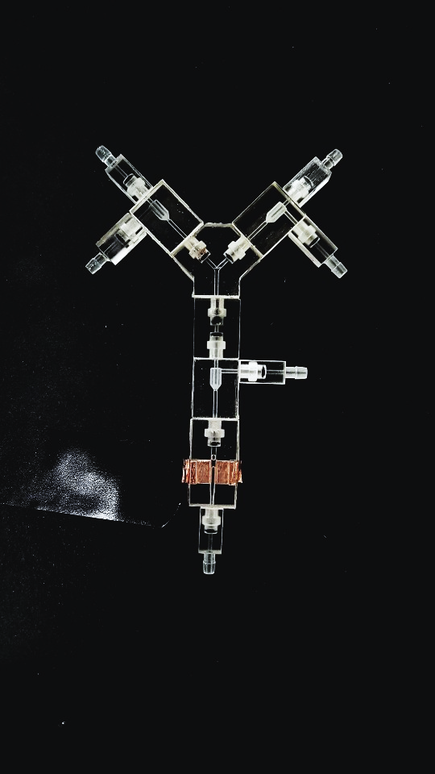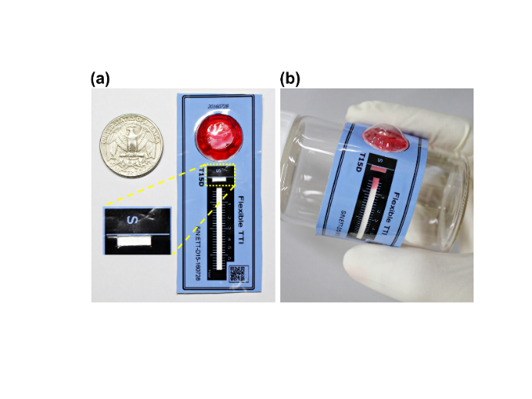

***Prof. Jinkee Lee received B.S. and M.S. degrees in Mechanical Engineering from Korea Advanced Institute of Science and Technology (KAIST), Korea in 1997 and 1999, respectively, and Ph.D. degree from Brown University in 2008, where he held the prestigious Simon Ostrach Fellowship. Following his graduate studies, he was a Postdoctoral Research Fellow at jointly in School of Engineering and Applied Science and Department of Organismic and Evolutionary Biology in Harvard University from 2008 to 2009, then moved back to Brown University as an Assistant Professor in School of Engineering from 2009 to 2011. In 2012, he joined Sungkyunkwan University (SKKU), where he is currently Associate Professor and Director of Multiscale Fluid Mechanics Laboratory in School of Mechanical Engineering and Institute of Quantum Biophysics.***



***His research interests are the Interfacial Flow & Transport Phenomena and their Applications falls under the area of Mechanical Engineering, Chemical Engineering, Material Science, Physics and Micro-/Nano-Technologies. He has published over 70 peer-reviewed journal articles. He is a recipient of the KSME Kasan Research Excellence Award (2020), SKKU Presidential Teaching Award (2016) and Excellence Award by the Ministry of SMEs and Startups(2016).***